Portugal: History, Popular Attractions, Food, and Culture

Page 1: Historical Overview
Portugal, located on the Iberian Peninsula, has a rich and complex history that dates back thousands of years. The region was inhabited by Celtic tribes before becoming part of the Roman Empire. After the fall of Rome, it was ruled by Visigoths and later invaded by Moors in the 8th century. The Christian Reconquista culminated in the formation of the Kingdom of Portugal in 1139 under King Afonso I. Portugal rose to prominence during the Age of Discoveries in the 15th and 16th centuries, establishing a global empire with colonies in Africa, Asia, and South America. This era brought immense wealth and cultural exchange. However, the decline of the empire in the 17th century, coupled with the 1755 Lisbon earthquake, marked a period of hardship. Portugal transitioned from monarchy to republic in 1910, endured decades of dictatorship, and finally embraced democracy after the Carnation Revolution in 1974. Today, Portugal is a modern European nation, proud of its heritage and traditions.

Map of Portugal
The below picture is map of Portugal
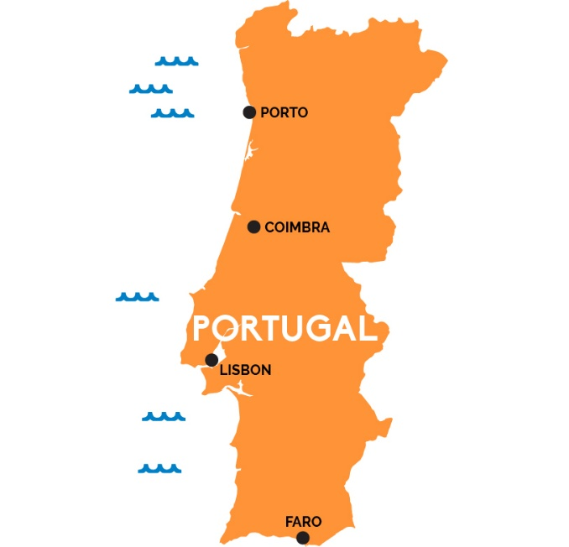
The above picture is map of Portugal

Page 2: Popular Attractions
Portugal is renowned for its diverse landscapes and iconic landmarks. Lisbon, the capital, offers historic neighborhoods like Alfama and Belém, where visitors can explore the Jerónimos Monastery and the Tower of Belém. Porto, famous for its wine, boasts the Ribeira district and the Dom Luís I Bridge. The Algarve region is celebrated for its stunning beaches, cliffs, and resorts. Sintra, a UNESCO World Heritage site, captivates with its fairy-tale palaces such as Pena Palace and Quinta da Regaleira. Coimbra, home to one of Europe’s oldest universities, showcases medieval architecture and vibrant student traditions. Beyond cities, Portugal’s natural wonders include the Douro Valley vineyards, the Azores archipelago with volcanic landscapes, and Madeira’s lush mountains. These attractions highlight Portugal’s blend of history, nature, and modernity.

Dimension of machine is below as image
The below picture is image of Dimension of machine
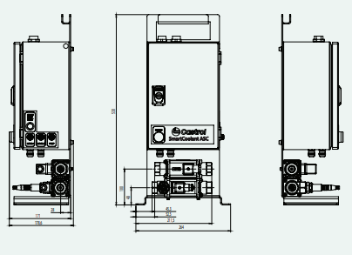
The above picture is image of Dimension of machine
Dimension of machine / image of machine / caption: Machine overall dimensions

Page 3: Portuguese Cuisine
Portuguese food reflects the nation’s maritime heritage and regional diversity. Seafood plays a central role, with dishes like bacalhau (salted cod), grilled sardines, and octopus. Caldo verde, a kale and potato soup, is a staple comfort food. The influence of colonial trade introduced spices such as piri-piri, used in chicken dishes. Pastéis de nata, custard tarts, are beloved worldwide. Porto is synonymous with francesinha, a hearty sandwich layered with meat, cheese, and sauce. The Algarve offers cataplana, a seafood stew cooked in a traditional copper pan. Portugal’s wines, especially Port and Vinho Verde, are internationally acclaimed. Olive oil, bread, and cheese also form essential parts of daily meals. Portuguese cuisine emphasizes simplicity, freshness, and bold flavors, making it a cornerstone of the nation’s identity.

Page 4: Culture and Traditions
Portuguese culture is deeply rooted in its history and shaped by global influences. Fado, a melancholic music genre, expresses themes of longing and fate, and is recognized by UNESCO as intangible cultural heritage. Festivals are vibrant, such as Carnival, São João in Porto, and Santo António in Lisbon. Religious traditions remain strong, with pilgrimages to Fátima attracting millions. Portugal’s art and architecture reflect Gothic, Manueline, and Baroque styles, while azulejos (ceramic tiles) adorn buildings with intricate designs. Literature flourished with poets like Luís de Camões, whose epic “Os Lusíadas” celebrates the Age of Discoveries. Modern Portuguese cinema and contemporary art continue to gain international recognition. Family and community are central to social life, with hospitality and warmth defining Portuguese interactions.

Page 5: Modern Portugal
Today, Portugal balances tradition with innovation. It is a member of the European Union, with a growing economy driven by tourism, technology, and renewable energy. Lisbon has become a hub for startups and digital nomads, while Porto thrives as a cultural and economic center. Portugal is celebrated for its quality of life, safety, and sustainability initiatives. The country invests in preserving its heritage while embracing modern challenges such as climate change and globalization. Portuguese people take pride in their resilience, creativity, and openness to the world. From its historic roots to its dynamic present, Portugal remains a nation of rich culture, delicious food, and captivating landscapes, offering a unique blend of past and future.

📄 Additional Sample Data (Paragraph Format)

👤 Employee 1
Michael Chen is a DevOps Engineer in the Cloud Infrastructure team at TechNova Solutions. He works on Project Orion, which focuses on cloud automation and deployment pipelines. Michael collaborates closely with the AI Platform team and reports to Emily Davis, the Head of Cloud Engineering.

👤 Employee 2
Emily Davis is the Head of Cloud Engineering and leads the Cloud Infrastructure team. She manages Michael Chen and Rajesh Kumar and oversees multiple cloud transformation initiatives including Project Orion. Emily reports directly to David Lee and works closely with other engineering leaders.

👤 Employee 3
Rajesh Kumar is a Cloud Architect in the Cloud Infrastructure team. He is responsible for designing scalable cloud solutions and is currently working on Project Orion along with Michael Chen. Rajesh reports to Emily Davis and frequently collaborates with the AI Platform team for integrating AI workloads.

👤 Employee 4
Anita Verma is a Product Manager in the Digital Solutions team. She owns Project Atlas and is responsible for defining product requirements and coordinating between engineering and business teams. Anita works closely with Sarah Johnson and her team and reports to Lisa Wong, the Director of Product Management.

👤 Employee 5
Lisa Wong is the Director of Product Management at TechNova Solutions. She leads the Digital Solutions team and manages Anita Verma. Lisa is responsible for overseeing product strategy across multiple projects including Project Atlas and reports to the Chief Technology Officer.

Employee Details
employee_id | employee_name | department | role | reporting_to_employee_id
10000 | Martha | Accounts | Sr Manager | 10002
10001 | Joao Marcio | Accounts | Manager | 10000
10001 | Crociao | Accounts | Associate | 10000
10002 | Joao Chorondo | HR | Manager
10003 | Crociao | HR | Associate | 10002

